|  |
| --- |
|  |
| Business Plan |
| Bjorn Harvold  Paul Fisher  Benjamin Taylor  Erik Aass |
|  |

|  |
| --- |
|  |

Contents

1.0 Mission Statement 2

1.1 Key Values 2

1.2 Key Goals 3

2.0 Value Proposition 3

2.1 Industry Analysis 4

2.3 Business Issue 4

2.4 Solution 4

2.5 Evidence 6

3.0 Target Market 6

3.1 Customers 6

3.2 Marketing & Promotions 7

3.3 Competition 8

4.0 Privacy 9

5.0 The revenue streams 9

5.1 Subscription service 9

5.2 Professional consulting 9

5.3 Government grants 9

5.4 Phase 2 -3 Revenue streams 9

6.0 Management Summary 10

6.1 Management Team 10

7.0 Activities 11

8.0 Key Stakeholders 11

9.0 The cost structure 11

10.0 Break-even 12

Appendix 13

Appendix 1: Project Manager Bio 13

Appendix 2: Proposed Development Team 13

Appendix 3: ARRA HITECH Physician Funding 14

Appendix 4: ARRA HITECH Hospital Funding 14

Appendix 5: E-Vendor Relationship Matrix 14

Appendix 6: Competitive Analysis 15

Appendix 7: Income Statement 15

Appendix 8: Financials 16

Appendix 9: Discounted Cash Flow Analysis 17

Appendix 10: Profitability 17

# 1.0 Mission Statement

Health XCEL is striving to transform electronic information management for healthcare providers and institutions by delivering an open, interoperable[1], standardized, *e-healthcare* *network* with the ability to securely share and review sensitive patient information and communicate seamlessly through the Internet.

1.1 Key Values

Health XCEL, Inc. is a provider of enterprise e-health[2] software services that enable healthcare professionals to securely exchange health related information while giving e-health vendors a platform on which to create interoperable applications for the future.

Our goal is to revolutionize the healthcare data management industry by offering centralized access to distributed data. Health XCEL software allows EHRs (Electronic Health Records)[3] to be shared between currently incompatible data systems. In addition to this, Health XCEL will offer services to help install and integrate the software with the current EHR system.

| **Now** | **Health XCEL** |
| --- | --- |
|  |  |

The future of e-health lies in a centralized solution with a service and subscription model where healthcare providers outsource their internal IT infrastructures to an organization that can satisfy their needs. Healthcare Professionals can then focus on what they do best: healing people and the e-health organization can focus on what they do best: managing data. Health XCEL has created a Health Information Exchange (HIE)[4], a network which gives health professionals the ability to electronically store and transmit an individual’s health records.

Health XCEL’s e-health software platform, **GlobalHealth,** supports the needs of healthcare professionals and e-health vendors. This platform enables the creation and secure sharing of sensitive patient information by using online relationship management tools.

By creating a patient-centric, e-health network on top of this platform Health XCEL will deliver services that enable healthcare professionals and service providers an increased capability to manage critical health data needed for more informed healthcare delivery -- delivery that will dramatically cut costs for healthcare professionals while increasing efficiency. The overall result will be improved healthcare and reduced costs for all stakeholders. Healthcare professionals will have access to health records when and where they need them and control the flow of information. Ultimately, the healthcare related risks for both patients and physicians are reduced through improved communication and access to important healthcare related data.

1.2 Key Goals

For Health XCEL to achieve success it must attain the following goals.

* [5]
* Raise $1 million through government grants and private sector financing
* Sign on at least two small to mid-size customers[6]
* Execute a targeted marketing campaign
* Execute an awareness strategy for U.S. and EU e-health regulators
* Retain a marketing healthcare firm with veteran healthcare expertise[7]
* Contract a project manager (Appendix 1)
* Contract seven senior developers (Appendix 2)

# 2.0 Value Proposition

2.1 Industry Analysis

The healthcare industry is poised for an internal revolution. Currently, it is inefficient and often working on antiquated and expensive data systems and “the bulk of medical records are locked up in paper files”.[8] The healthcare industry currently works in silos. They rarely share information and use disparate systems to store data.

The US government is pushing e-health and EHRs, through the $19.2 billion Health Information Technology for Economic and Clinical Health (HITECH) Act. This authorizes eligible healthcare professionals and hospitals to qualify for Medicare and Medicaid incentive payments when they adopt certified EHR technology and use it to achieve specified objectives according to federally specified “meaningful use” standards. [9]

2.2 Macro Trends“Obamacare” (Patient Protection and Affordable Care Act) imposes mandates on doctors and hospitals that require them to begin using EHRs to store their patients’ medical data.

The “baby boom” generation will require more drugs and services as it ages and impose massive increases on healthcare budgets for governments and organizations.[10] With successively smaller generations to support the growing population of the elderly, costs will have to be cut. E-health is a highly effective way for governments to manage healthcare costs in the decades to come.

E-health helps to control costs by reducing administrative expenses, facilitating scheduling and reducing redundancy of care. E-health is an integral component to solving demand related issues while improving quality of care.

2.3 Business Issue

The current state of e-health is somewhat analogous to the early days of the Internet, when users were restricted to retrieving basic information rather than interacting with each other through for example social media. Most healthcare information currently still resides in hard-to-access silos (a.k.a. paper documents in filing cabinets) and most business practices are often antiquated. Health XCEL is adapting the current innovations of the Internet to modernize these backward practices and apply them to the e-health space.

Just as electronic document centers decrease costs and increase available office space through a convergence of functionalities, our product, **GlobalHealth** unifies data protocols and tools and facilitates communication.

2.4 Solution

Health XCEL’s flagship product, **GlobalHealth**, is a centralized, cloud-based software platform that lets e-health vendors develop, test and deploy secure, scalable and interoperable e-health applications. This platform provides hospitals, healthcare professionals and insurance companies with the tools to manage sensitive information and enables them to communicate seamlessly. Most importantly it will connect patients to their providers by allowing them to view and manage their own healthcare records.

**GlobalHealth** solves the most significant problem facing e-health today: interoperability. This is accomplished by centralizing the solution, and using existing medical standards for sharing records. Interoperability is the cornerstone of this new model of Healthcare as a Service (HeCaaS). Built on the widely adopted Platform as a Service (PaaS)[11] and Software as a Service (SaaS)[12] models, we let providers choose what applications they wish to subscribe to from a variety of available services.

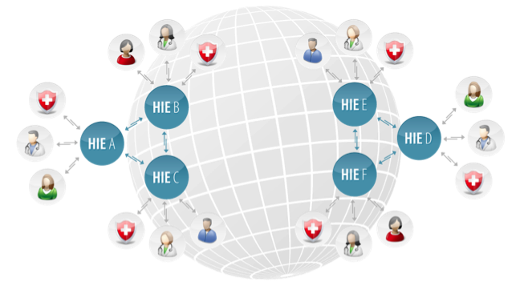

In the picture above, you can see patients and healthcare professionals interacting with their regional HIE services, which in turn, synchronizes their data with other HIEs around the globe.

The most important e-health application Health XCEL provides is an advanced Electronic Health Record (EHR) solution that allows institutional, professional and patient stakeholders the ability to share and review sensitive patient information and communicate seamlessly and securely through the Internet. Billing and scheduling functionality will also be integrated with the EHR.

**GlobalHealth:**

* Shifts the focus from provider to patient; giving patients greater control of their own well being
* Shifts data management away from providers and onto our secure Health Information Exchanges (HIE)
* Provides e-health vendors with a full lifecycle, software platform to develop e-health applications on

The overall result is better service rendered to the patient. Patients and physicians will have access to health records when and where they need them. The patient controls the flow of information. Ultimately, the healthcare related risks for both patients and healthcare professionals are reduced through improved communication and access to important healthcare related data, thereby drastically reducing the cost of litigation or reporting errors.

2.5 Evidence

The U.S. government has allocated $66 million for research and development of e-health solutions and raised annual spending through the Office of the National Coordinator for Health Information Technology (ONCHIT). The goal is for every U.S. citizen to have an EHR by 2014. It has been estimated that a successful implementation of e-health can save the U.S. more than a trillion dollars. The EU has already spent €500 million in research for the development of e-health tools and systems since the early 1990s. They have allocated another €50 billion to be disbursed from 2007 to 2013.

There is general consensus that e-health solutions are the answer to spiraling healthcare expenses but it is unclear how this will be achieved. The EU member countries have agreed that legislation needs to be changed to help promote free flow of healthcare information across borders. The U.S. wrote the Health Insurance Portability Accountability Act (HIPPA) and the Certification Commission for Health Information Technology (CCHIT) specifications to help vendors.

E-health IT expenditures in the U.S. were $7.6 billion in 2006 and are expected to rise to $12 billion by 2011.[13] EU expenditures represented €19 billion in 2006 and are expected to increase to €35 billion by 2013, approximately 84% percent growth over less than 6 years.

There will be a significant increase in demand for e-health solutions. Improving the systems that manage information is the best way to ensure quality of service and reduce costs.

# 3.0 Target Market

3.1 Customers

Though Health XCEL provides solutions which healthcare professionals and large healthcare institutions and even national health systems can use to offload the information management aspect of healthcare and in the process save hundreds of millions of dollars we will in the intial stages focus our attention on appealing directly to smaller healthcare practices which can immediately leverage the benefits of our products and services while giving their patients personalized attention.

**Health Professionals**

**GlobalHealth** will make health professionals more efficient, less prone to misdiagnoses, and give them access to more patient information than ever before. This is also where we see an advantageous niche market of small to mid-sized practices that are already tech savvy and would be eager to try our services. Additionally, the American Recovery and Reinvestment Act (ARRA) provides physicians with up to $44,000 in financial incentives to adopt EHRs. (Appendix 3)

**E-health vendors**

E-health vendors are our 3rd party counterparts. They will work closely with us and become our certified solution providers. They create and support custom applications that are built for our enterprise clients. (Appendix 5)

3.2 Marketing & Promotions

When Health XCEL first launches **GlobalHealth**, the target audiences will be second tier individual and small practice healthcare professionals (physical therapists, chiropractors, etc) and their patients who want to have an online EHR. All patient-physician features will be complete such as relationship management, scheduling, EHR, etc. An example of an ideal customer is *onemedical.com*, a highly tech savvy, small New York City-based practice, with existing scheduling and prescription refill software modules.

We will promote the web site in trade magazines, through medical associations and medical journals that cater to our users. We want our first audience to be computer savvy without large elaborate antiquated systems or boxes of old paper-based records lying around. We want to target those who can immediately see our application as a solution to a problem and not as a tertiary nuisance. Physicians at hospitals are usually bogged down with old systems and paper based record keeping and will not want to embrace something new as quickly as our desired target audience.

Medical associations can also help us establish our reputation. With their “stamp of approval” our customers will feel more confident migrating to our network. As we accumulate these stamps of approval, a foundation will be made that we are a company that can be trusted. Our marketing efforts go hand-in-hand with our goal of market acceptance.

We intend to retain a marketing and advertising agency with healthcare experience and built-in knowledge and contacts in the industry. Hiring an outside agency to handle marketing will save on expenses and is a more effective way to gain access to professionals with e-health specific experience.

3.3 Competition

There are several regional, state sponsored, initiatives under way that promote EHRs. The Federal Government has deferred the issue to the individual states. There has been movement in the e-health market sector but no convergence, resulting in a patchwork of solutions without a unifying body. Currently, no one has successfully created an HIE platform such as ours.

We do, however, have competitors across several segments of the e-healthcare industry. Below we have outlined seven companies that fit into two different market segments; the B2B and the B2C markets. The institution-oriented competitors are companies that cater to hospitals and other large providers while patient oriented companies cater to the average user. (Appendix 6)

**Institution oriented (B2B)**

* eClinicalWorks ([www.eclinicalworks.com](http://www.eclinicalworks.com/))
* Cerner ([www.cerner.com](http://www.cerner.com/))
* MedSites ([www.med-sites.com](http://www.med-sites.com/))

**Patient oriented (B2C)**

* WebMd **(**[www.webmd.com](http://www.webmd.com/))
* Revolution Health ([www.revolutionhealth.com](http://www.revolutionhealth.com/))
* Microsoft HealthVault ([www.healthvault.com](http://www.healthvault.com/))
* Google Health ([http://health.google.com](http://health.google.com/))

# 4.0 Privacy

Privacy is a major concern as it is the subject of intense government regulation. The HIPAA (Health Insurance Portability Accountability Act) Privacy Rule provides federal protections for personal health information held by covered entities and gives patients an array of rights with respect to that information.

EHRs will actually enhance the privacy of individual patients. There are two major reasons for this. The first is that new technologies provide a tremendous array of mechanisms to protect privacy. The second is that the existing alternative, paper records are highly fallible when it comes to protecting privacy. Along with avoiding dangerous medical mistakes, reducing costs, and improving care, the computerization of health records will improve the privacy and security of health information. The EHR, when maintained according to the HIPAA Privacy and Security Rules, actually offers more safeguards than the paper record.

# 5.0 The revenue streams

5.1 Subscription service

The main revenue stream for HealthXcel will be the subscription service we charge hospitals and healthcare practices to use **GlobalHealth**. We will charge $20 per patient per year and offer per patient licenses with volume discounts. Providers will buy licenses in packages of 250, 500, 1000 etc. We will provide rollover discounts much like cell phone companies for unused subscriptions.

5.2 Professional consulting

We will provide professional consulting services to customers who want custom applications that are not offered as part of our basic package of services. We foresee the applications marketplace to quickly gain traction as vendors discover the platform’s potential and as our customers become more demanding and want more custom applications. Consulting services will be on a T&M basis and we will charge $250 per hour.

5.3 Government grants

The Federal government has set aside large grants in an effort to see to it that every citizen has an EHR by 2014. Some of the Grants which we are monitoring include:

* Utilizing Health Information Technology (IT) to Improve Healthcare Quality (R18)
* Exploratory and Developmental Grant to Improve Healthcare Quality through Health Information Technology (IT) (R21) (up to $200,000 in funding)
* Small Research Grant to Improve Healthcare Quality through Health Information Technology (IT) (R03)

5.4 Phase 2 -3 Revenue streams

In the second and third phase of our plan rollout, we plan to introduce *revenue sharing*. This is a multi-tier marketing opportunity and recruiting tool. Health professionals will have the opportunity to create a “virtual practice” within our system. A virtual practice consists of a group of physicians who are paying for any of our monthly services. We will create incentives for “owners” of virtual practices to recruit as many professionals as possible. The reward will be a percentage of the total monthly subscription fee of all the new members recruited. The more members an owner can recruit, the higher the percentage rate she will receive. The goal for an owner is to recruit to the company’s maximum capacity but also to recruit the customers who pay the highest subscription fees.

The incentive for a physician to join such a company is the monthly discount she receives. She gets a greater discount based on how well the company is doing.

# 6.0 Management Summary

Health XCEL's personnel will initially consist of the original four person management team which will oversee software development, sales and marketing and day to day operations. The firm will, in the initial stage, limit new hires and rely on contractors (pre-identified) to fill the software development and project manager roles. We will outsource most other functions including marketing and sales and payroll to outside firms, to save on G&A expenses.

6.1 Management Team

**CEO, Bjorn E. Harvold** - founded Health XCEL Inc. in 2004. Bjorn has over 12 years of experience in software development. Previously he has founded an entertainment company, a stock photography agency, a mobile payment solutions provider and co-founded a software architecture firm. Throughout his career he has done software consulting work for Adobe Systems, Conde Nast, Sun Microsystems, Chase Bank, PriceWaterhouseCoopers, DraftFCB, Accoona and Intela.

**COO, Paul T. Fisher** - developed a distance learning application for neuroscience, at Johns Hopkins University. He co-founded SmartPants Media, Inc., a software development company which has created interactive software, kiosks, and games for organizations such as the IMF, Smithsonian Institution, and trafficLand.com. Paul was until recently the Director of Technology at wired.com and is currently the Chief Engineer at limewire.com.

**CIO, Benjamin G. Taylor** - is a career entrepreneur and consultant with extensive knowledge in the application of technology to new business models. He has over 12 years of experience and has worked with senior management at clients such as AT&T, MBNA, UPS, Nokia, Hallmark, Telstra and PacBell. Ben’s last venture was as founder of Enpresence, a social networking site focused on connecting people via GPS and Bluetooth-based services.

**CFO, Erik P. Aass** (Notre Dame, MBA 2011) - is working to develop the business model and plan with Health XCEL. He has three years experience working as an investment banker in New York City and is concentrating his studies in Corporate Finance and Business Leadership. He also has six years of leadership experience in the US Army and deployed to both Iraq and Afghanistan where he was decorated for valor in combat three times.

As Health XCEL matures it will eventually need to make additional hires in order to properly meet customer expectations and expand the business in line with the gradual expansion into the e-health marketplace.

The firm will secure office space in New York City, sufficient to accommodate the management team and new hires for the first year of operations. The company will lease server space.

# 7.0 Activities

Health XCEL must secure one million in financing in order to fully finance the first 3 years of operations. The company forecasts that it will become profitable in that period. The company must also identify personnel to assume the sales and marketing role prior to beginning operations. The firm must recruit people with industry experience. At our core, Health XCEL is a software development company and the most important key to success is securing the services of “rock star” software engineers.

The company needs a detailed marketing plan and a three year plan for growth to include a plan for new hires of staff and expansion into larger offices. Health XCEL must also increase awareness of its website, [www.hxcel.com](http://www.hxcel.com).

# 8.0 Key Stakeholders

As this is a client centric business our most critical stakeholders are the small to mid-size, tech savvy, healthcare practices, who would eagerly want to become more competitive by offering their patients superior services without paying exorbitant license fees. By using **GlobalHealth** to pay per active patient, they can reduce their costs and still enjoy all the services we offer.

What makes and breaks most software development projects is a dearth of good developers. Most of the projects that fail, do so because, in an attempt to save, they are outsourced to lower priced, less skilled developers, under the supervision of weak project managers.

To fully develop and implement **GlobalHealth** it is vital that we retain the services of a team of top-ranked software developers and a well respected and experienced project manager. We have already identified and reached out to a team with the requisite skills and particular experience to successfully carry out this project. These individuals were chosen because of their professionalism and talent and commitment to improving the efficiency of the healthcare industry. They are attracted by the prospect of working on an intellectually challenging and meaningful project and will be compensated above the industry average.

# 9.0 The cost structure

The biggest cost will be developing the **GlobalHealth** software from its current prototype stage to a fully launchable software platform. We estimate that this project will require a contracted team of seven developers and one project manager over a three year period to complete and install the first versions of the software.

Health XCEL’s main expense will be labor which, calculated at current rates for highly qualified software developers, will be approximately $1.5 million dollars per year.

Additionally, there will be a minimal amount of G&A expenses to operate the firm’s offices and the fee to retain a marketing firm. First year expenses are expected to total $ 4.8 million.

# 10.0 Break-even

Assuming that Health XCEL is able to attract a major healthcare institution and sign two small to midsized clients the company expects to break even half-way through its second year of operations. Management intends to “bootstrap” $400,000 and raise another $ 4.6 million to fund the first three years operations. Based on a three year time horizon this project has a positive NPV of $ 27.1 million and IRR of 179%. (Appendix 9)

# Appendix

Appendix 1: Project Manager Bio

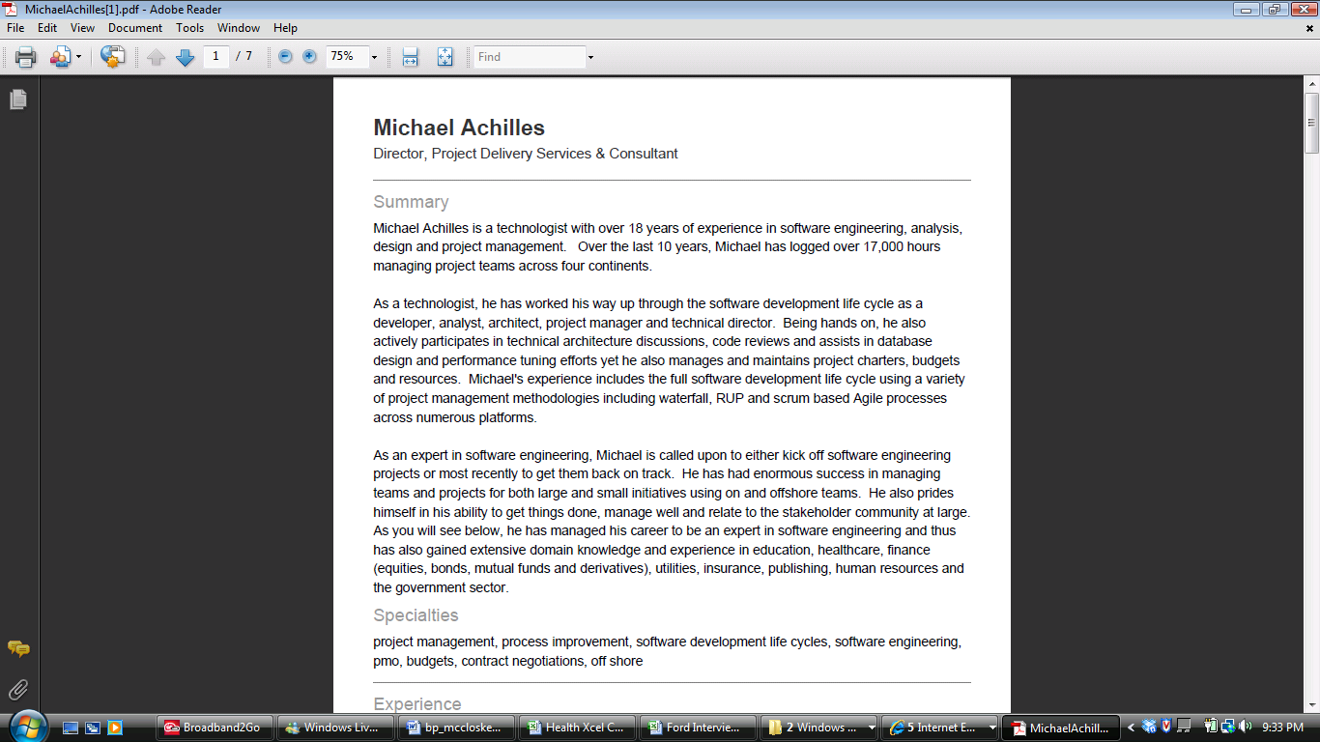

Appendix 2: Proposed Development Team



Appendix 3: ARRA HITECH Physician Funding

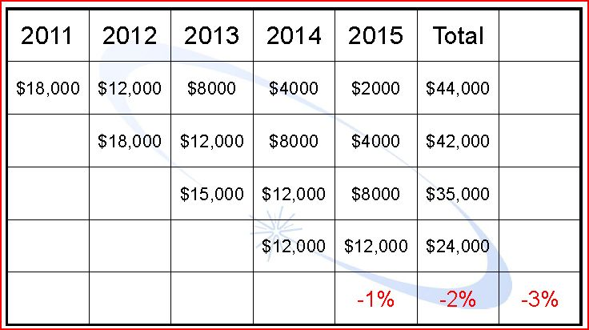

Appendix 4: ARRA HITECH Hospital Funding

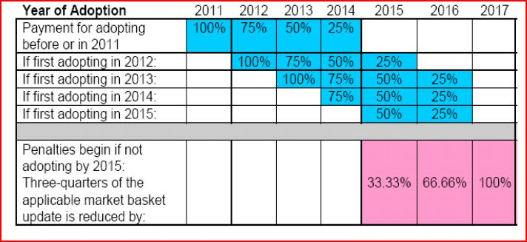

Appendix 5: E-Vendor Relationship Matrix

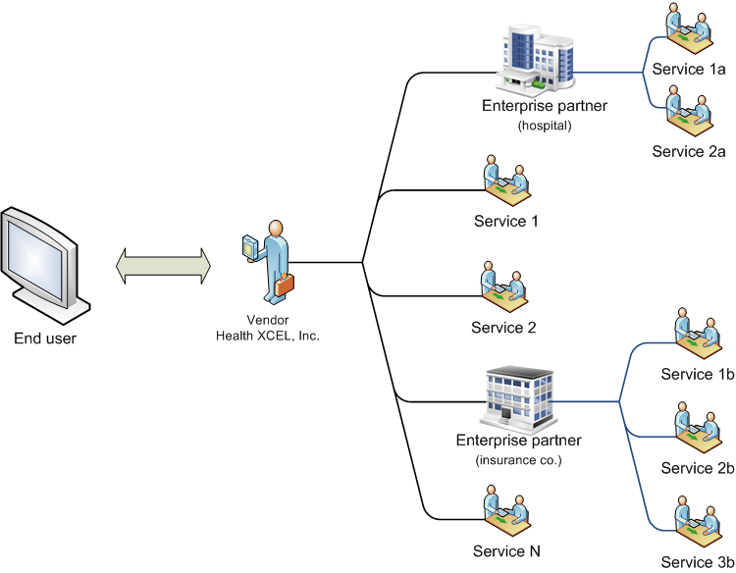

Appendix 6: Competitive Analysis

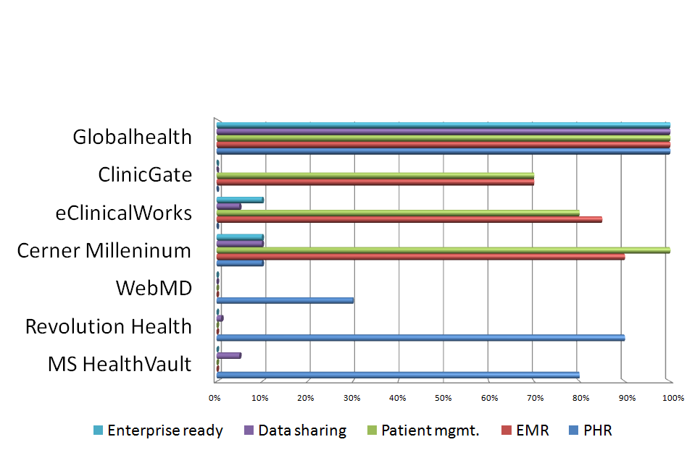

Appendix 7: Income Statement



Appendix 8: Financials



Appendix 9: Discounted Cash Flow Analysis



Appendix 10: Profitability



1. **Interoperability is** the ability of two or more systems or components to exchange information and to use the information that has been exchanged.
2. **e-health** is a term for healthcare practice supported by electronic processes and communication.*-- Oh et al. "What Is e-health: A Systematic Review of Published Definitions." J Med Internet Res 2005;7(1):e1*
3. **Electronic Health Record (EHR)** is an evolving concept defined as a systematic collection of electronic health information about individual patients or populations. It is a record in digital format that is capable of being shared across different healthcare settings, by being embedded in network-connected enterprise-wide information systems. Such records may include a whole range of data in comprehensive or summary form, including demographics, medical history, medication and allergies, immunization status, laboratory test results, radiology images, vital signs, personal stats like age and weight, and billing information.
4. **Health Information Exchange** (HIE) is defined as the mobilization of healthcare information electronically across organizations within a region, community or hospital system.HIE provides the capability to electronically move clinical information among disparate [healthcare](http://en.wikipedia.org/wiki/Health_care) information systems while maintaining the meaning of the information being exchanged. The goal of HIE is to facilitate access to and retrieval of clinical data to provide safer, more timely, efficient, effective, equitable, patient-centered care. HIE is also useful to [Public Health](http://en.wikipedia.org/wiki/Public_Health) authorities to assist in [analyses of the health of the population](http://en.wikipedia.org/wiki/Clinical_surveillance).

   *--ONCHIT*
5. Healthcare Corporation of America: http://www.hcahealthcare.com/
6. www.onemedical.com
7. www.abelsontaylor.com
8. http://www.bnet.com/blog/healthcare-business/health-information-exchanges-are-hopping-but-doctors-may-not-be-ready... Retrieved January 30, 2011.
9. http://healthit.hhs.gov
10. Centers for Medicare and Medicaid Services, Office of the Actuary, National Health Statistics Group, National Healthcare Expenditures Data, January 2010.
11. **Platform as a Service (PaaS)** is the delivery of a computing platform and solution stack as a service. PaaS offerings facilitate deployment of applications without the cost and complexity of buying and managing the underlying hardware and software and provisioning hosting capabilities, providing all of the facilities required to support the complete life cycle of building and delivering [web applications](https://secure.wikimedia.org/wikipedia/en/wiki/Web_application) and [services](https://secure.wikimedia.org/wikipedia/en/wiki/Web_service) entirely available from the Internet.
12. **Software as a service** (SaaS) sometimes referred to as "software on demand," is software that is [deployed](https://secure.wikimedia.org/wikipedia/en/wiki/Software_deployment) over the internet and/or is deployed to run behind a firewall on a local area network or personal computer. With SaaS, a [provider](https://secure.wikimedia.org/wikipedia/en/wiki/Provider) licenses an application to customers either as a [service](https://secure.wikimedia.org/wikipedia/en/wiki/Web_service) on demand, through a subscription, in a "pay-as-you-go" model, or (increasingly) at no charge when there is opportunity to generate revenue from streams other than the user, such as from advertisement or user list sales. This approach to application delivery is part of the [utility computing](https://secure.wikimedia.org/wikipedia/en/wiki/Utility_computing) model where all of the technology is in the "cloud" accessed over the Internet as a service. *--Software & Information Industry Association*
13. Landers, Peter WSJ: Health Spending Rose To Record 17.6% Of US Economy In 2009, 5 January 2011,